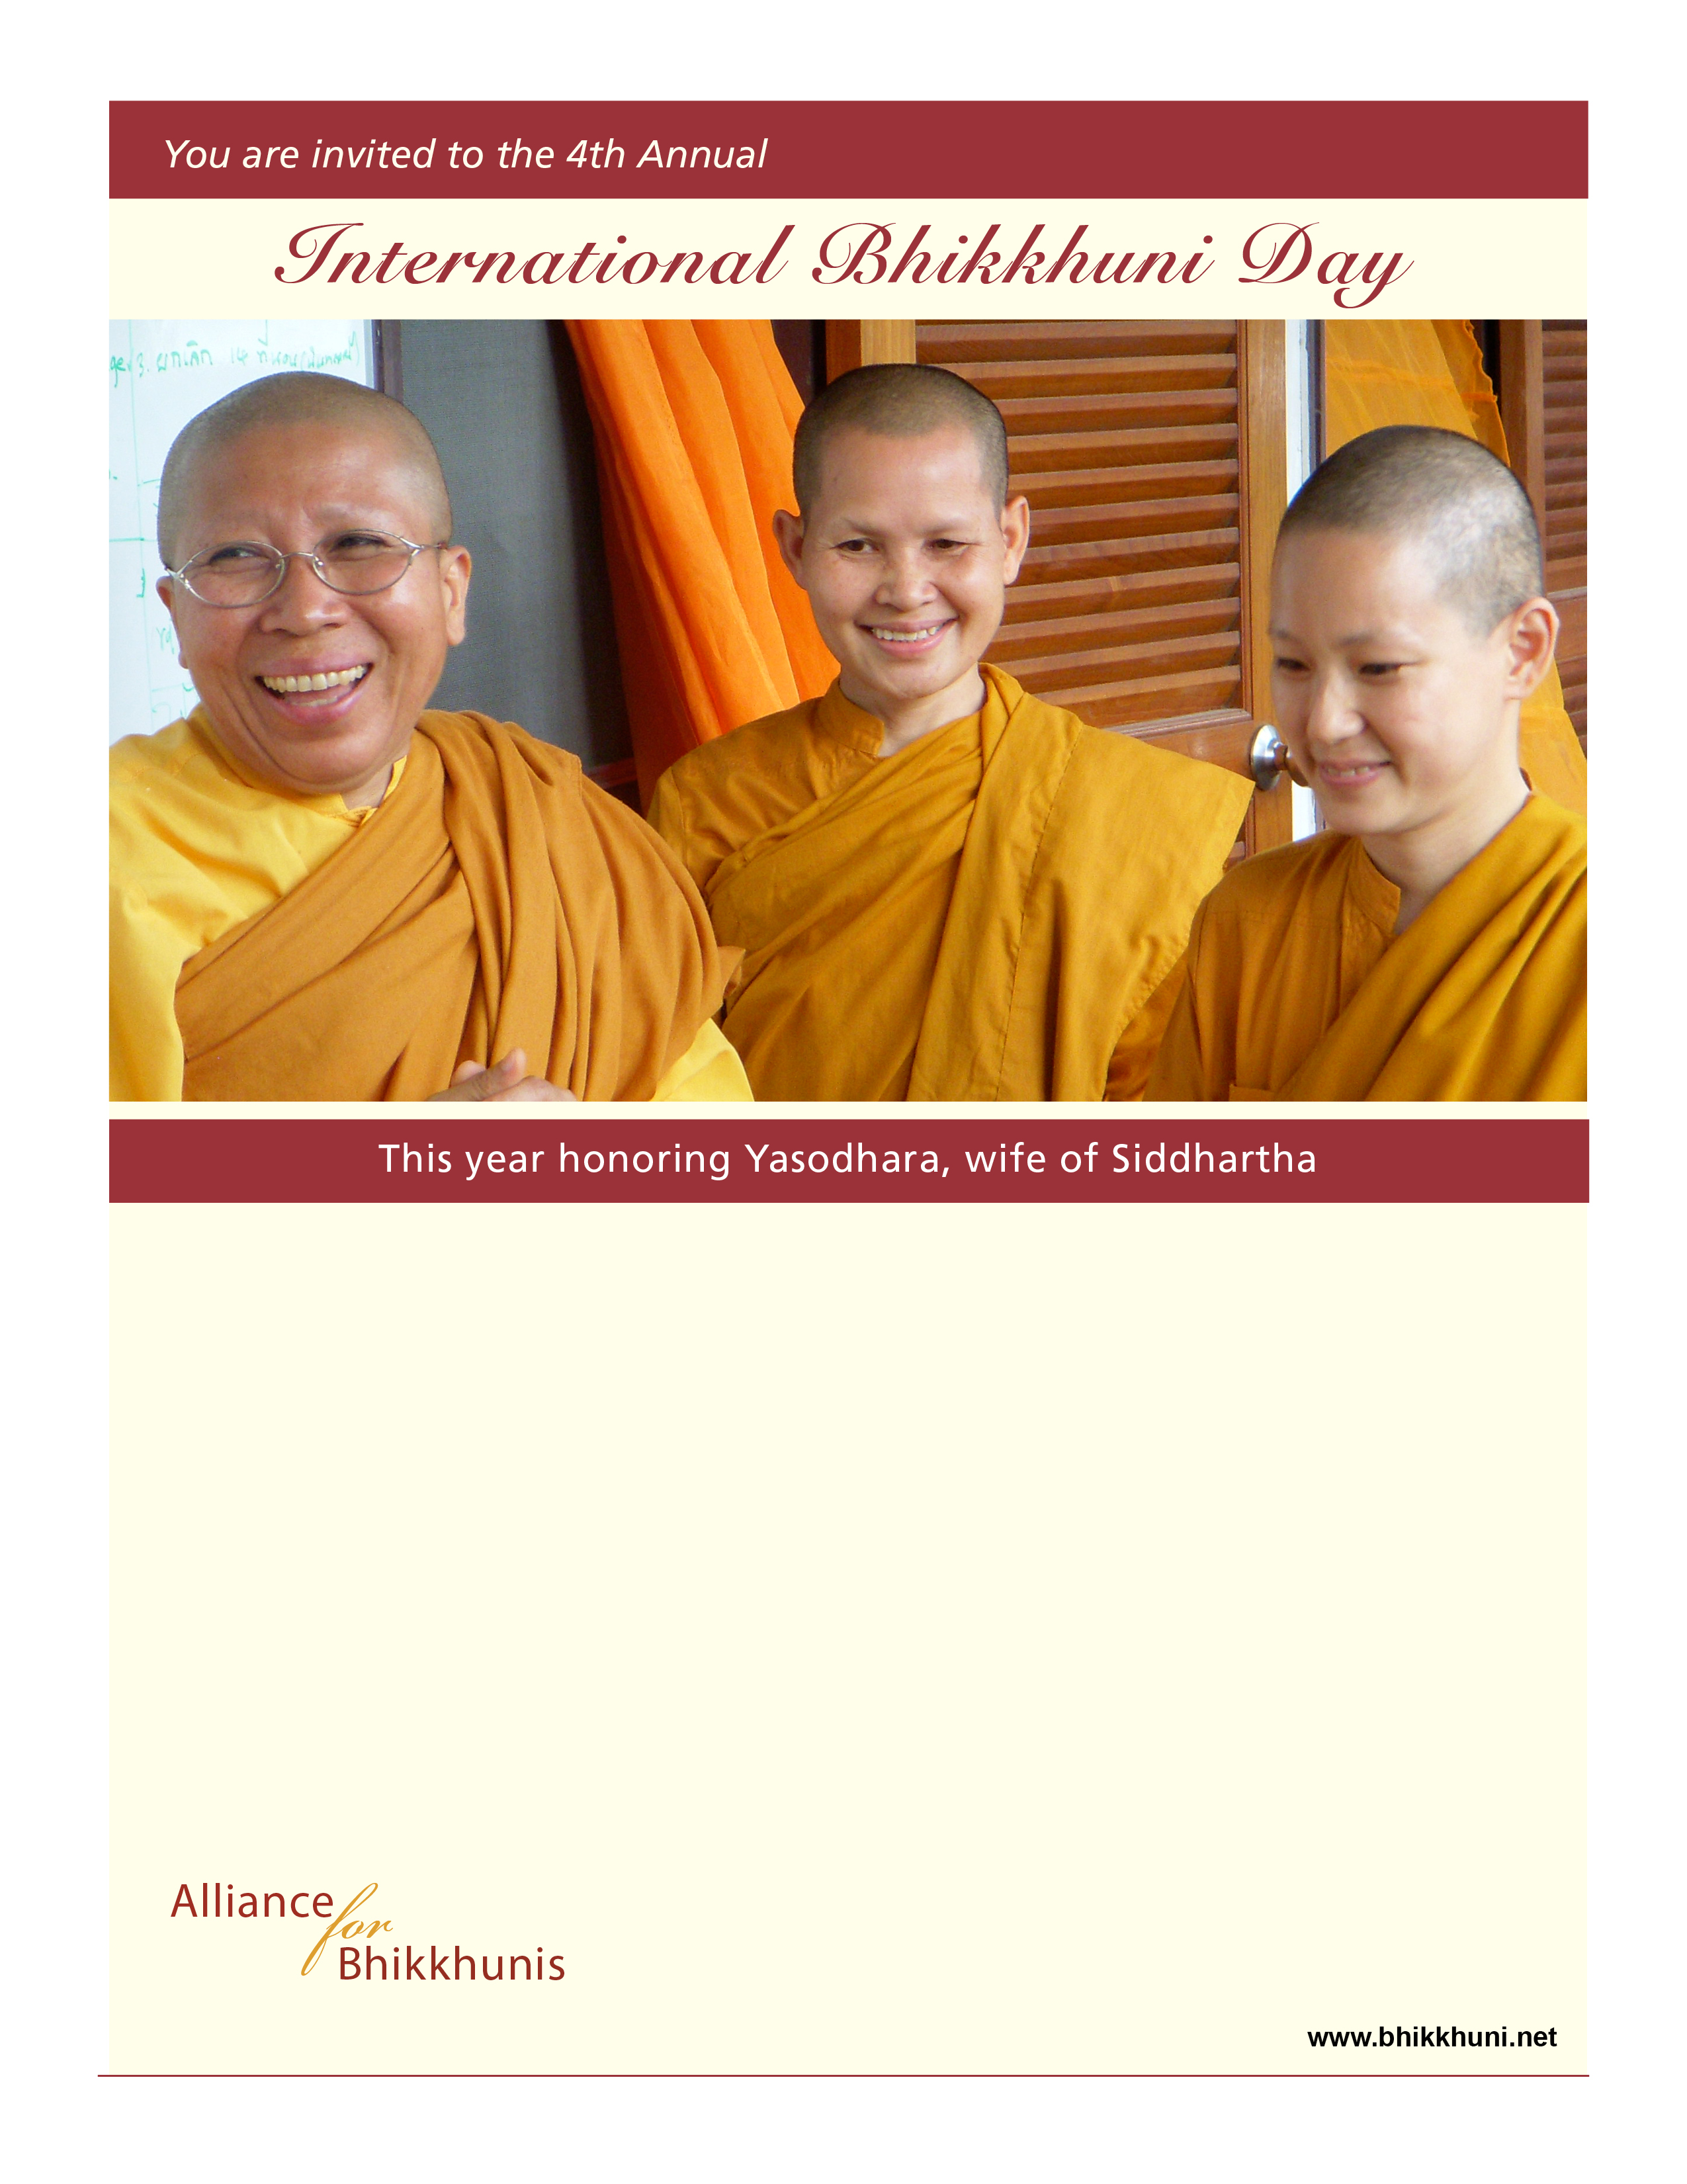­

Join us in celebrating our female spiritual legacy and the

re-emergence of fully ordained Buddhist women (Bhikkhunis). On this day we honor ordained women and inspiring historical figures. This is a time to acknowledge and learn from these women, whose wisdom from the earliest days of the Buddha to the present have brought a greater truth and a deeper understanding of life from the perspective of spiritual awakening.

Traditionally on International Bhikkhuni Day, we select one woman who exemplifies this spiritual accomplishment. This year we pay respect especially to Yasodhara, wife of Siddhartha Gautama, one of the Buddha’s 13 great Bhikkhuni disciples, and a fully enlightened Arahant.

We look forward to your participation in this time of   
spiritual celebration, meditation, and reflection.

**DATE**

time

address

phone